**1-Introduction**

These instructions are designed to help Data Processing and Sampling specialists to adapt and deploy “HH Listing” applications. It is important to mention that manual: “CAPI HH Listing Manual Final.docx” describing the HH Listing system including the Central office, is available in standard project under folder \Docs.

**2-Folders required by the HH Listing system**

It is recommended that the entire HH Listing system is adapted and stored in a folder with name “cc81L”. Where, cc corresponds to the country code and the “L” is used to differentiate this folder from folders used for DHS/MIS. The HH Listing system is designed in such a way that it runs indistinctly in Windows or Android Operating System (OS). Of course, the central office component only works in windows. The following folders from the standard project are needed:

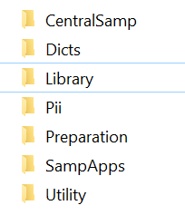

**2.1 Folder \Dicts**

This folder has the dictionaries needed by the system. The following dictionaries are required.

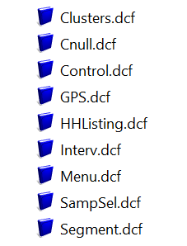

**2.2 Folder \SampApps**

In this folder is where all applications for the HH Listing fieldwork operation are stored.

**2.3 Folder \CentralSamp**

This folder contains applications needed for the central office. In application CentSampMenu, it is necessary to change variable “android”. This variable should have a value 1 if the data is coming through CSWeb , otherwise it should have a value of 0.

**2.4 Folder \Preparation**

This folder contains the applications necessary to:

* Register the enumerators that will participate in the fieldwork operation, defined by dictionary “Interv.dcf”.
* The system requires a file with the clusters to be visited to list their households. Clusters are defined according to dictionary “Clusters.dcf”.
* There is also an option in the preparation system to generate a control file necessary for the central office. The control file is defined by dictionary “Control.dcf”.

**2.5 Folder \Pii**

Three folders are necessary here:

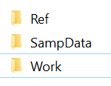

**2.5.1 folder \ref**

The three auxiliary files described in the previous paragraph are stored in this folder. The names of the files are “Clusters.dat”, “Interv.dat”, and “LControl.dat”. The application used to generate the control file, creates it with name “Control.data” and therefore it needs to be renamed as “LControl.dat”.

**2.5.2 folder \SampData**

In this folder is where data created by the HH listing system are created. Essentially, three files are created:

* LYYYYXXXX.dat – To store the actual households listed in a cluster
* SYYYYXXXX.dat – To store segmentation data, when cluster has to be segmented
* GYYYYXXXX.dat - To store GPS coordinates when collected by cluster. When GPS coordinates are collected by household, they are included as part of households files

Where YYYY is the cluster number and XXXX corresponds to the enumerator

**2.5.3 folder \Work**

This folder is used by the central office system as a temporary working directory

**2.6 Folder \Utility**

Three folders are necessary here:

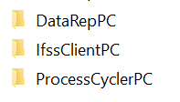

DataRepPC is used by the central office and it stores the utility “DataRepairpc.exe” necessary to repair data as described in the HH Listing manual. IfssClientPC and ProcessCyclerPC are necessary when deploying the HH Listing application in the Windows OS and if using IFSS for transferring data from the field to the central office. Folder \ProcessCycler contains the utility “ProcessCyclerPC.exe” to be used by enumerators and central office as a shortcut to enter into their respective menus systems. Files “process.txt” and “process Central Office.txt” needs to be adjusted to point to the correct folders. In the central office machine file “process Central Office.txt.txt” has to be renamed as just “process.txt”. The following figure depicts the IFSS configuration necessary if that approach is used in Windows for the HH Listing fieldwork operation.

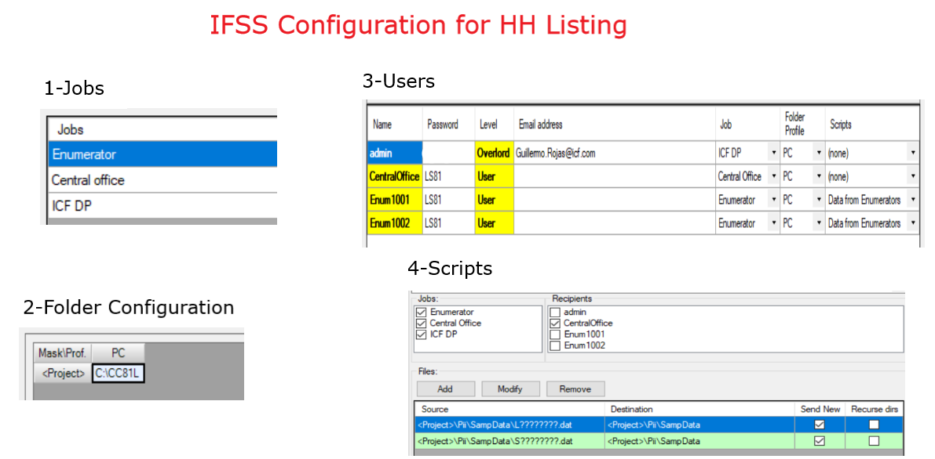

**3-CSWeb Configuration**

The following configuration setting variables were defined to get access to CSweb.

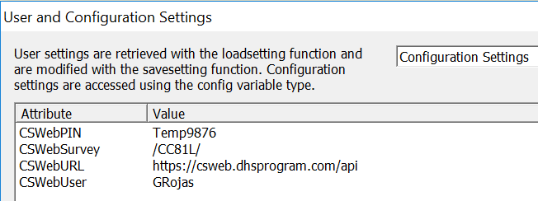

At this point Android is implemented to work on a CSWeb server. This same approach can be used for windows instead of using IFSS, by simply adjusting the instruction displayed below in SampMenu application. Actually, while adapting the system and for testing it in the windows environment, it is necessary to follow the comment until the developer is satisfied with the system’s functionality.

  if !SameSession & android then   // remove "& android" to test CSWeb with windows

Android only works with a CSWeb server, but it is possible that in the future both Windows and Android will work with SyncCloud instead.

Whether for Android or Windows, the figure below shows the configuration of the CSWeb server for a generic CC81L fieldwork operation. This server is available for DHS (<https://csweb.dhsprogram.com/>) and some of us can create usernames on a needed basis. It is possible to implement CSWeb in other servers, but this implementation was particularly designed by Blueraster for ICF and if required to be implemented in other servers, it needs Blueraster’s assistance. It is important that names of folders and files in CSWeb should have the same spelling in terms of lower and capital letters because that is a requirement for some Android machines.

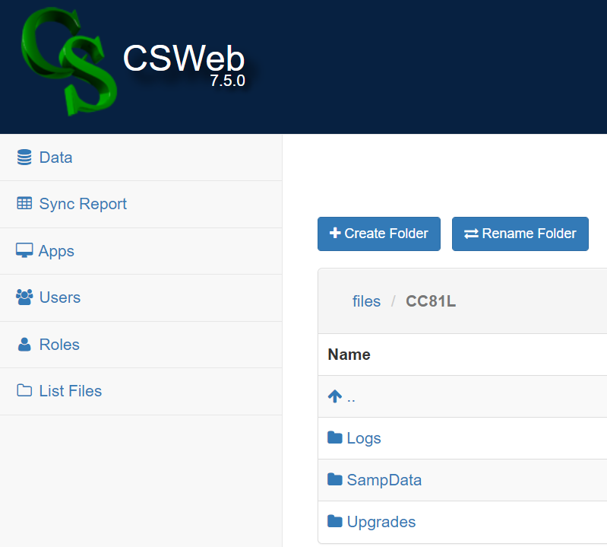

Folder \SampData is used to store data transferred by enumerators to the central office.

Folder \Logs stores files with information regarding connections to the server by each enumerator. Logs files are downloaded to folder “cc81L\Pii\Work” in the central office computer to monitor enumerators connections to CSWeb. Log file names are “SyncLogFileXXXX.txt” (where XXXX corresponds to the enumerators code). These files are created and maintained by the system. For every connection to CSWeb, a line is written in the file with information shown below.

Date=20210520 Time=1220 Prev_Upgr=00 N_Upgr=00 Menu Date=20210520 Time=1218

Date=20210520 Time=1223 Prev_Upgr=00 N_Upgr=01 Menu Date=20210520 Time=1218

Folder \Uprades is used to keep control of upgrades sent to enumerators. At the beginning of fieldwork, this folder should contain file: “FTPVersionCtrl.txt” as shown in the figure above. The file contains a record with the legend:

**Version 0**

This legend indicates that there haven’t been any upgrades zero (“0”) so far. For every upgrade, the version number should be manually increased by 1. At the same time inside \Upgrades a folder with name \UpdateXX should be manually created (where XX corresponds to version number). The files to be upgraded should then be uploaded to the created \UpdateXX folder. The system supports two types of upgrades: “.pen” and “.dat” files. “.pen” files are downloaded and copied to the folder where applications are stored and “.dat” files are copied to ../Pii/Ref folder.

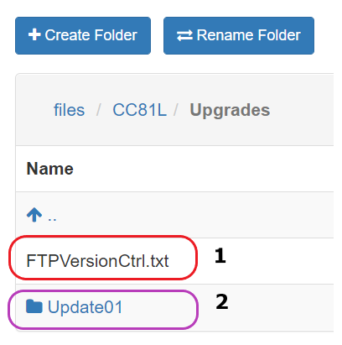

In summary sending upgrades to enumerators is a two steps process:

File FTPVersionCtrl.txt is deleted form CSWeb and later the modified version with the appropriate version number uploaded. It is recommended to manipulate this file in the \Upgrades folder of the DP/Sampling machine to have a good control of it. However, although not advisable, it is possible to directly edit the file on CSWeb.

A new folder \UpdateXX is created under \Upgrades and “.pen” or “.dat” files uploaded to the new created directory

**4-Android tablets set-up/organization**

These are the requirements to deploy the system in Android tablets.

Install the appropriate version of CSPro into the tablet. Instead of installing tablet by tablet from “Google store”, it is more convenient to get the APK installation form <http://csprousers.org/apk>.

Once CSPro is installed it creates a folder Called “CSentry” in the Android tablet. Under that folder the following directories are necessary:

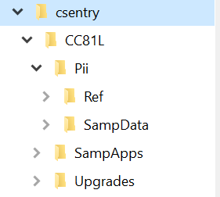

**4.1 Folder \SampApps**

This folder is used to store:

* SumpMenu.pff, a program information file recognized by CSPro as the starting point for the fieldwork HH listing system
* “.pen” files, one for each application used by the system
* HTML styles sheet (TablesStyles.css) file, used to display HTML reports
* SQL databases used for persistence purposes. For the HH Listing menu the database is called “SampMenu.db”. For the actual HH Listing application the database is called “SampList.db”
* Additionally all auxiliary files generated by applications as they are executed are generated here

The system in its initial state should look like this:

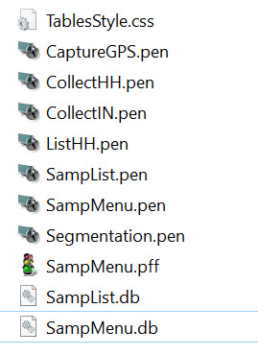

**4.2 Folder \Pii**

\Ref and \SampData subfolders store the same information as described in sections 2.5.1 and 2.5.2 above.

**4.3 Folder \Upgrades**

This folder is used by the system to keep track of upgrades installed to tablets. It has essentially the same functionality as the corresponding folder \Ugrades in CSWeb. The folder in its initial stage should only have the file “SampVersionCtrl.txt” and the content of the file is a record with the legend:

**Version 0**

When the HH Listing system connects to CSWeb it downloads the file “FTPVersionCtrl.txt”. Then it compares the version stored in this file with the version stored in “SampVersionCtrl.txt”. If the version coming from CSWeb is greater than the version in the tablet, it creates as many folders under this directory as necessary with names \UpdateXX (where XX is upgrade number). Then downloads the files containing in the corresponding folder in CSWeb to the recently created directory. After that copies then “.pen” and/or “.dat” files to the appropriate folder in the tablet. Right after this, file “SampVersionCtrl.txt” is updated with the version number applied.

In this folder is also where synchronization records in file “SyncLogXXXX.txt” (where XXXX corresponds to the enumerator’s code) are registered and later uploaded to the \Logs folder in CSWeb